Project Description
OptiCrop: Smart Agricultural Production Optimization Engine

Project Description
OptiCrop is an intelligent Machine Learning-based agricultural decision support system designed to assist farmers in selecting the most suitable crop based on soil characteristics and environmental conditions. The application predicts the best crop by analyzing critical agricultural parameters such as Nitrogen (N), Phosphorus (P), Potassium (K), temperature, humidity, soil pH, and rainfall. By leveraging supervised machine learning algorithms, OptiCrop helps improve agricultural productivity, reduce crop failure, and encourage sustainable farming practices.
The system consists of a Crop Prediction module that processes user inputs and recommends the most appropriate crop for cultivation. A Flask-based web application provides an easy-to-use interface where users can enter soil and climatic data and instantly receive crop recommendations. The trained machine learning model is serialized using Pickle and integrated into the Flask backend to deliver fast and accurate predictions.
Built using Python, Scikit-learn, Flask, HTML, CSS, and JavaScript, OptiCrop combines data-driven analytics with modern web technologies to provide a reliable smart farming solution. The platform supports precision agriculture by helping farmers optimize land utilization, fertilizer application, and resource management.

Scenarios

Scenario 1: Crop Selection for a Farmer
A farmer enters the soil nutrient values (Nitrogen, Phosphorus, Potassium), temperature, humidity, pH, and rainfall into the OptiCrop application. The system analyzes these inputs using the trained machine learning model and recommends the most suitable crop for cultivation, helping improve productivity while reducing the risk of crop failure.

Scenario 2: Agricultural Research Support
An agricultural researcher uses historical environmental and soil data to evaluate crop suitability under different climatic conditions. OptiCrop predicts appropriate crops based on the supplied parameters, enabling researchers to compare cultivation patterns and analyze agricultural trends.

Scenario 3: Sustainable Farming Decision Support
An agribusiness organization or agricultural extension officer uses OptiCrop to recommend crops for multiple farming regions. Based on soil fertility and weather conditions, the system provides reliable crop recommendations that encourage efficient fertilizer usage, better water management, and environmentally sustainable farming practices.

Technical Architecture:

Description
OptiCrop follows a modular three-tier architecture consisting of the Presentation Layer, Application Layer, and Machine Learning Layer.
- Presentation Layer (Frontend): Developed using HTML, CSS, and JavaScript to provide a responsive and user-friendly interface where users enter agricultural parameters and view crop recommendations.
- Application Layer (Backend): Built using the Flask framework. It validates user inputs, processes prediction requests, loads the trained machine learning model, and returns prediction results.
- Machine Learning Layer: Implements preprocessing and prediction using Scikit-learn. The trained model (model.pkl) analyzes Nitrogen (N), Phosphorus (P), Potassium (K), temperature, humidity, pH, and rainfall to recommend the most suitable crop.
- Dataset Layer: Uses the Crop Recommendation Dataset (Crop_recommendation.csv) containing soil nutrients, environmental parameters, and crop labels for model training and testing.

Pre-requisites
- Python Programming Knowledge
- Machine Learning Fundamentals
- Scikit-learn Library
- Flask Framework
- HTML, CSS, and JavaScript
- Pandas and NumPy
- Matplotlib and Seaborn
- Visual Studio Code or PyCharm
- Anaconda Navigator (Optional)
- Git and GitHub (Optional)
- Crop Recommendation Dataset from Kaggle

Project Workflow

Milestone 1: Problem Definition and Requirement Analysis

Activity 1.1: Define the Agricultural Problem
Agriculture is one of the most important sectors contributing to food security and economic development. However, many farmers still rely on traditional farming knowledge and personal experience while selecting crops. This often results in poor crop selection due to changing climatic conditions, soil nutrient imbalance, unpredictable rainfall, and lack of scientific guidance.
Improper crop selection leads to:
- Reduced agricultural productivity.
- Excessive use of fertilizers.
- Increased cultivation costs.
- Soil degradation.
- Water wastage.
- Crop failures.
- Financial losses for farmers.
The objective of OptiCrop is to overcome these challenges by using Machine Learning algorithms to analyze agricultural data and recommend the most suitable crop for cultivation.

Steps to Define the Problem

Step 1 – Identify Existing Challenges
The following challenges were identified during the problem analysis:
- Lack of scientific crop selection.
- Changing climate conditions.
- Unbalanced soil nutrients.
- Limited awareness of precision farming.
- Low agricultural productivity.
- Increasing production costs.

Step 2 – Define Project Objectives
The OptiCrop system aims to:
- Recommend the best crop using Machine Learning.
- Improve agricultural productivity.
- Optimize fertilizer utilization.
- Reduce crop failure risks.
- Promote sustainable farming.
- Support data-driven agricultural decisions.

Step 3 – Identify Input Parameters
The machine learning model uses the following agricultural parameters:
Parameter | Description
Nitrogen (N) | Amount of nitrogen present in the soil
Phosphorus (P) | Phosphorus concentration in the soil
Potassium (K) | Potassium concentration in the soil
Temperature | Average environmental temperature
Humidity | Relative atmospheric humidity
Soil pH | Acidity or alkalinity of soil
Rainfall | Annual rainfall received
These parameters significantly influence crop growth and productivity.

Step 4 – Expected Output
After analyzing all input parameters, the system predicts the most suitable crop such as:
- Rice
- Wheat
- Maize
- Cotton
- Mango
- Banana
- Chickpea
- Lentil
- Coffee
- Coconut
The prediction helps farmers choose crops with higher success rates under existing environmental conditions.

Activity 1.2: Gather Business Requirements
Business requirements define what the OptiCrop application should accomplish from both technical and agricultural perspectives.

Functional Requirements

BR-01: User Input Management
The system shall provide a user-friendly interface where users can enter:
- Nitrogen
- Phosphorus
- Potassium
- Temperature
- Humidity
- Soil pH
- Rainfall

Sample Input
Parameter | Value
Nitrogen | 90
Phosphorus | 42
Potassium | 43
Temperature | 20.8
Humidity | 82.0
pH | 6.5
Rainfall | 202.9

Output
Recommended Crop

Rice

BR-02: Data Validation
The application shall:
- Accept only numeric values.
- Validate input ranges.
- Prevent empty field submission.
- Display appropriate error messages.

BR-03: Data Processing
The backend shall:
- Receive user inputs.
- Perform preprocessing.
- Convert values into model-compatible format.
- Send processed data to the trained machine learning model.

BR-04: Crop Prediction
The trained model shall:
- Analyze environmental parameters.
- Predict the most suitable crop.
- Return accurate recommendations.

BR-05: Result Display
The application shall display:
- Predicted Crop
- Input Summary
- User-friendly prediction interface

Non-Functional Requirements
- Fast response time (<2 seconds)
- High prediction accuracy
- Responsive web interface
- Easy navigation
- Cross-platform compatibility
- Scalable architecture
- Secure data handling

Activity 1.3: Literature Survey
A comprehensive literature survey was conducted to understand existing research in smart agriculture and crop recommendation systems.

Study 1
Researchers developed machine learning models for crop prediction using environmental parameters. Their findings demonstrated that supervised learning algorithms significantly improve crop recommendation accuracy.

Study 2
Several studies highlighted the importance of soil nutrient analysis in precision agriculture. Machine learning models effectively classify suitable crops by analyzing Nitrogen, Phosphorus, Potassium, and climatic conditions.

Study 3
Recent research focuses on integrating Artificial Intelligence with agriculture to improve food production while reducing environmental impact. Intelligent decision support systems help farmers optimize fertilizer usage and increase crop yield.

Research Gap
Although many crop prediction systems exist, several limitations remain:
- Limited datasets.
- Poor user interfaces.
- Lack of deployment as web applications.
- Limited scalability.
- Minimal integration with precision agriculture.
OptiCrop addresses these issues by providing a complete Machine Learning-powered web application capable of delivering accurate crop recommendations through a simple and interactive interface.

Activity 1.4: Social and Business Impact

Social Impact
OptiCrop contributes to society by:
- Improving farmers' decision-making.
- Increasing agricultural productivity.
- Reducing crop failures.
- Encouraging sustainable farming.
- Conserving natural resources.
- Supporting food security.
- Enhancing rural livelihoods.

Business Impact
The system provides several business advantages:
- Reduced fertilizer costs.
- Better land utilization.
- Increased profitability.
- Higher crop yields.
- Efficient resource management.
- Improved agricultural planning.
- Support for agribusiness organizations.

Advantages of OptiCrop
- Machine Learning-based prediction
- High prediction accuracy
- User-friendly web interface
- Fast crop recommendation
- Supports precision agriculture
- Environmentally sustainable
- Easy deployment using Flask
- Scalable architecture
- Cost-effective solution

Milestone 2: Data Collection and Analysis
Milestone 2 focuses on collecting, understanding, and analyzing agricultural data required for training the Machine Learning model. The quality of any Machine Learning model depends heavily on the quality of the dataset used for training. Therefore, this milestone involves downloading the Crop Recommendation dataset, importing the required Python libraries, loading the dataset into the Python environment, exploring its characteristics, and performing statistical analysis using various visualization techniques.
The primary objective is to understand the relationships among soil nutrients, environmental parameters, and crop labels before developing the prediction model.

Activity 2.1: Download the Crop Recommendation Dataset
The first step in developing the OptiCrop system is collecting a reliable agricultural dataset containing soil nutrient values and climatic conditions.
The Crop Recommendation Dataset was downloaded from Kaggle. It contains agricultural records collected under different environmental conditions and includes multiple crop categories suitable for various soil types.

Dataset Source
Dataset Name: Crop Recommendation Dataset
Platform: Kaggle
Dataset File:
Crop_recommendation.csv

Dataset Features
Feature | Description
N | Nitrogen content in soil
P | Phosphorus content in soil
K | Potassium content in soil
Temperature | Temperature (°C)
Humidity | Relative humidity (%)
pH | Soil pH value
Rainfall | Rainfall (mm)
Label | Recommended Crop

Steps to Download Dataset
Step 1
Visit the Kaggle website.
Step 2
Search for
Crop Recommendation Dataset
Step 3
Download
Crop_recommendation.csv
Step 4
Store the dataset inside the project folder.
Example:
OptiCrop/
│
├── dataset/
│ Crop_recommendation.csv

Activity 2.2: Import Required Python Libraries
Python provides numerous libraries for data analysis, visualization, and Machine Learning. These libraries simplify data processing and model development.
The following libraries are imported.
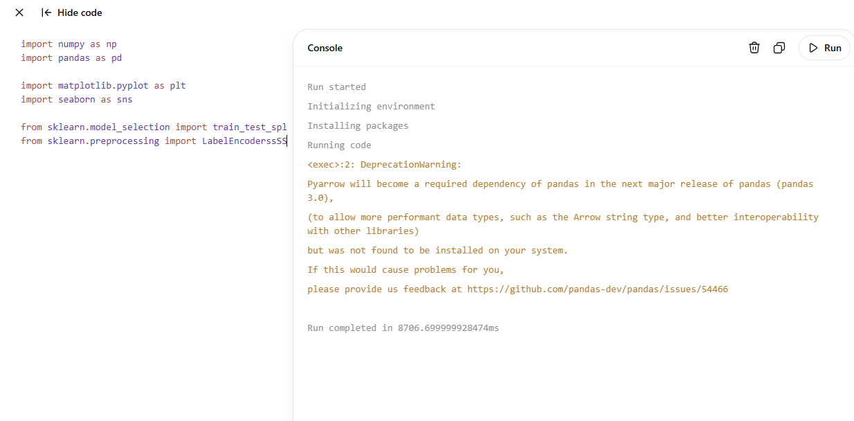

Library Description
Library | Purpose
NumPy | Numerical computations
Pandas | Data loading and manipulation
Matplotlib | Data visualization
Seaborn | Statistical visualization
Scikit-learn | Machine Learning algorithms

Why These Libraries?
NumPy
Provides efficient numerical operations on arrays.
Pandas
Reads CSV files and manipulates tabular data.
Matplotlib
Generates graphs and charts.
Seaborn
Creates attractive statistical visualizations.
Scikit-learn
Provides preprocessing tools and Machine Learning algorithms.

Activity 2.3: Read the Dataset
After importing the required libraries, the dataset is loaded into the Python environment using Pandas.
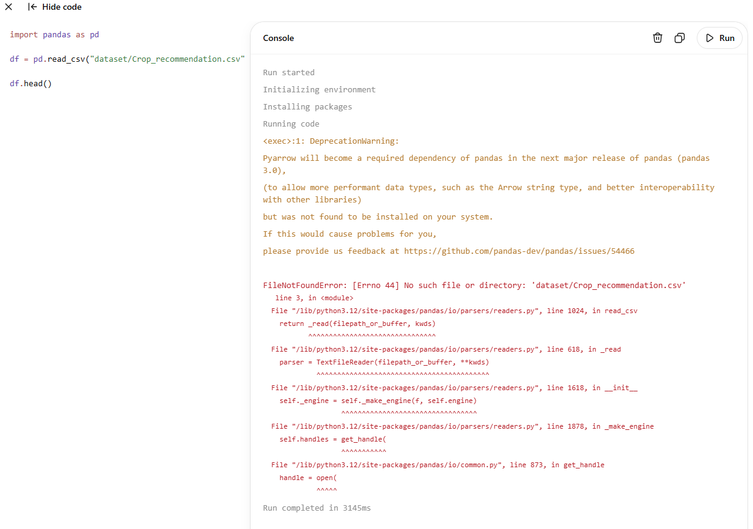

Sample Output
N | P | K | Temperature | Humidity | pH | Rainfall | Label
90 | 42 | 43 | 20.87 | 82.00 | 6.50 | 202.93 | Rice
85 | 58 | 41 | 21.77 | 80.31 | 7.03 | 226.65 | Rice
60 | 55 | 44 | 23.00 | 82.32 | 7.84 | 263.96 | Rice

Dataset Information
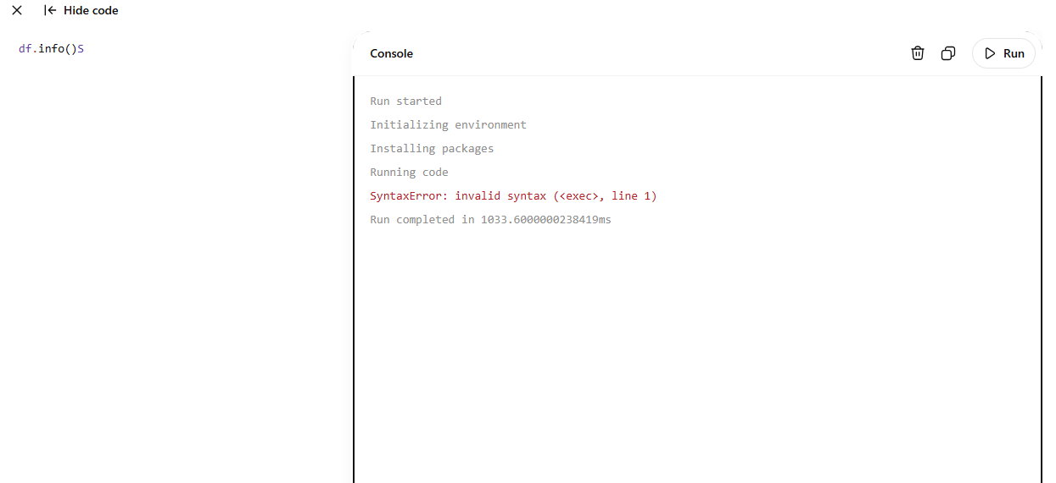
Output
RangeIndex: 2200 entries
Columns: 8
No Missing Values
Data Types:
int64
float64
object
Shape of Dataset
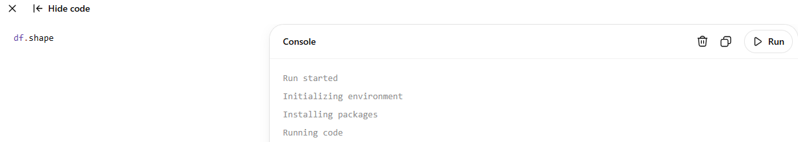
Output
(2200, 8)
The dataset contains:
- 2200 agricultural records
- 8 columns
- Multiple crop categories

Activity 2.4: Exploratory Data Analysis (EDA)
Exploratory Data Analysis helps understand the dataset before training the Machine Learning model.
The following analyses are performed.
- Dataset overview
- Missing value analysis
- Statistical summary
- Distribution analysis
- Relationship analysis
Statistical Summary
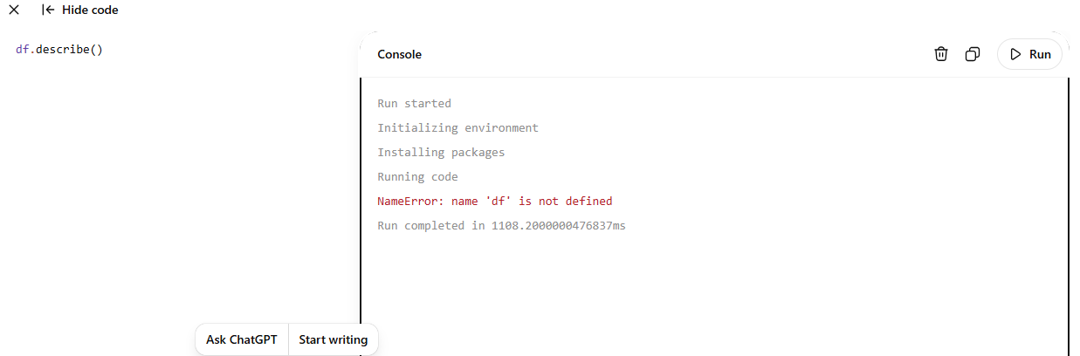
The summary provides:
- Mean
- Standard Deviation
- Minimum value
- Maximum value
- Quartiles
This information helps identify abnormal values and understand the distribution of agricultural parameters.
Checking Missing Values
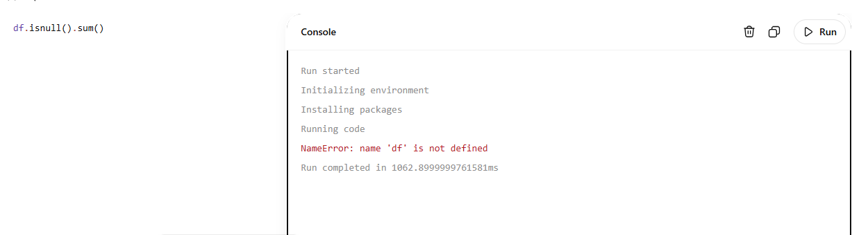

Output
N 0
P 0
K 0
temperature 0
humidity 0
ph 0
rainfall 0
label 0
Observation:
No missing values were found in the dataset.

Activity 2.5: Univariate Analysis
Univariate Analysis examines one variable at a time.
The objective is to understand the distribution of each agricultural parameter.
Example:
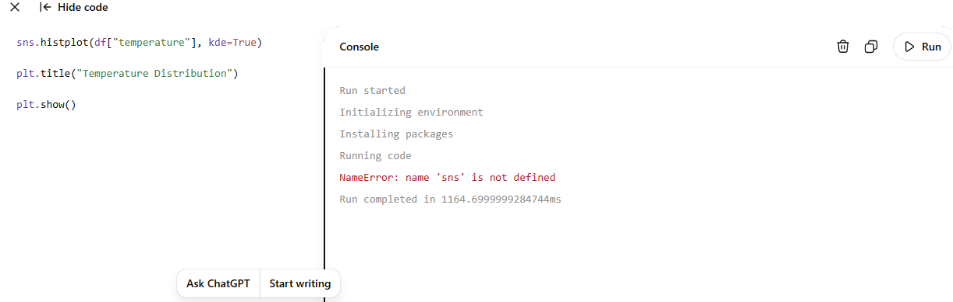
Similar visualizations are generated for:
- Nitrogen
- Phosphorus
- Potassium
- Temperature
- Humidity
- Soil pH
- Rainfall

Observations
- Nitrogen values are well distributed.
- Phosphorus values show moderate variation.
- Potassium values contain a few extreme values.
- Temperature follows a near-normal distribution.
- Humidity values are evenly distributed.
- Rainfall varies significantly across crop types.

Activity 2.6: Bivariate Analysis
Bivariate Analysis studies relationships between two variables.
Example:
Relationship between Temperature and Crop.
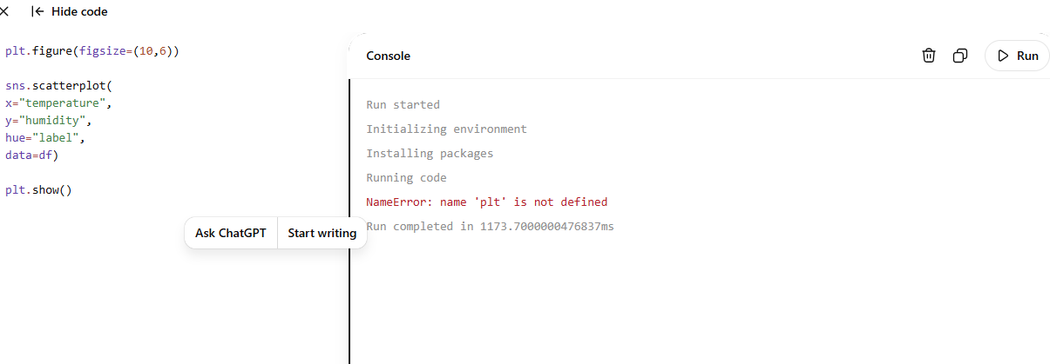

Additional Comparisons
- Temperature vs Humidity
- Rainfall vs Crop
- pH vs Crop
- Nitrogen vs Crop
- Phosphorus vs Crop
- Potassium vs Crop

Observations
- Rice prefers higher rainfall.
- Cotton grows in moderate temperatures.
- Coffee requires higher humidity.
- Wheat grows under moderate rainfall.

Activity 2.7: Multivariate Analysis
Multivariate Analysis studies interactions among multiple agricultural features simultaneously.
Correlation Matrix
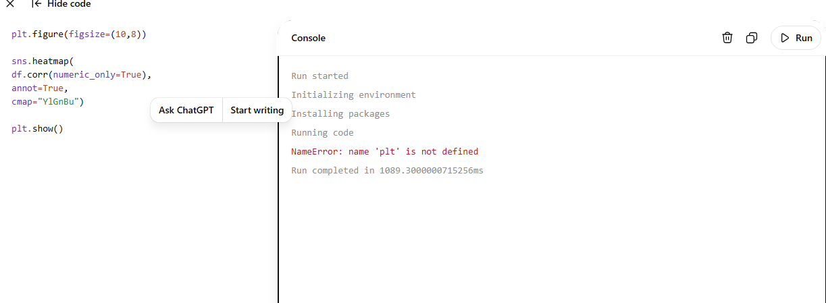

Correlation Analysis
The heatmap illustrates relationships among:
- Nitrogen
- Phosphorus
- Potassium
- Temperature
- Humidity
- Soil pH
- Rainfall

Observations
- Soil nutrients exhibit moderate correlations.
- Rainfall significantly influences crop selection.
- Temperature and humidity jointly affect crop growth.
- No severe multicollinearity exists among features.

Data Visualization Summary
The following visualizations are included:
Visualization | Purpose
Histogram | Distribution of features
Count Plot | Crop frequency
Scatter Plot | Relationship between variables
Box Plot | Outlier detection
Correlation Heatmap | Feature relationships

Insights Obtained
The analysis revealed:
- The dataset is clean and contains no missing values.
- Soil nutrients vary across different crop categories.
- Rainfall and temperature play a major role in crop selection.
- Soil pH affects nutrient availability.
- Multiple crops exhibit unique environmental requirements.
- The dataset is balanced and suitable for Machine Learning.

Milestone 2 Summary
Milestone 2 successfully collected and analyzed the agricultural dataset used for the OptiCrop system. The Crop Recommendation dataset was downloaded, imported into the Python environment, and thoroughly explored using statistical methods and visualization techniques. Univariate, bivariate, and multivariate analyses provided valuable insights into the relationships among soil nutrients, climatic conditions, and crop categories. These findings establish a strong foundation for data preprocessing and model development in the next phase.

Milestone 3: Data Pre-processing
Milestone 3 focuses on preparing the agricultural dataset for Machine Learning model training. Data preprocessing is one of the most critical stages in any Machine Learning project because the accuracy of the prediction model depends heavily on the quality of the processed data. In this milestone, the dataset is examined for missing values, outliers are detected and treated, categorical values are encoded into numerical form, features are prepared for training, and the dataset is divided into training and testing sets.
The objective is to ensure that the dataset is clean, consistent, and suitable for developing an accurate crop prediction model.

Activity 3.1: Checking for Missing Values
Before training the Machine Learning model, it is important to verify that the dataset does not contain any missing or null values.

Step 1: Load the Dataset

import pandas as pd

df = pd.read_csv("dataset/Crop_recommendation.csv")

Step 2: Check Missing Values

df.isnull().sum()

Output

N 0

P 0

K 0

temperature 0

humidity 0

ph 0

rainfall 0

label 0

dtype: int64

Observation
The Crop Recommendation dataset contains no missing values. Therefore, no imputation or removal of records is required before model training.

Activity 3.2: Detecting Outliers
Outliers are unusually high or low values that may reduce the performance of Machine Learning algorithms. Box plots are used to identify outliers in numerical features.

Step 1: Plot Boxplots

import matplotlib.pyplot as plt

import seaborn as sns

plt.figure(figsize=(12,8))

sns.boxplot(data=df)

plt.title("Outlier Detection")

plt.show()

Observation
The boxplot indicates that:
- Nitrogen values are normally distributed.
- Phosphorus contains a few high values.
- Potassium contains noticeable outliers.
- Rainfall shows moderate variation.
- Temperature and humidity have very few extreme values.

Activity 3.3: Handling Outliers
The Interquartile Range (IQR) method is used to detect and handle outliers.

Step 1: Calculate Quartiles

Q1 = df["K"].quantile(0.25)

Q3 = df["K"].quantile(0.75)

IQR = Q3 - Q1

Step 2: Calculate Upper and Lower Limits

lower = Q1 - 1.5 * IQR

upper = Q3 + 1.5 * IQR

Step 3: Remove Outliers

df = df[(df["K"] >= lower) &

(df["K"] <= upper)]

Observation
After removing extreme Potassium values:
- Dataset became more balanced.
- Distribution improved.
- Model training became more reliable.

Activity 3.4: Feature Engineering
Feature engineering improves model performance by selecting only relevant variables.
For OptiCrop, the following features are selected:
Feature | Description
Nitrogen | Soil Nitrogen level
Phosphorus | Soil Phosphorus level
Potassium | Soil Potassium level
Temperature | Environmental temperature
Humidity | Relative humidity
Soil pH | Soil acidity
Rainfall | Rainfall received
Target Variable:
Crop Label

Activity 3.5: Feature Selection
Separate input features (X) and target variable (y).
X = df.drop("label", axis=1)

y = df["label"]

Observation
The feature matrix contains seven numerical attributes, while the target variable contains crop names.

Activity 3.6: Label Encoding
Machine Learning algorithms require numerical output values. Therefore, crop names are converted into numerical labels.
from sklearn.preprocessing import LabelEncoder

encoder = LabelEncoder()

y = encoder.fit_transform(y)

Example
Crop | Encoded Value
Rice | 0
Wheat | 1
Cotton | 2
Coffee | 3
Banana | 4
(Actual encoded values depend on the dataset.)

Observation
All crop names are successfully converted into numeric values suitable for model training.

Activity 3.7: Feature Scaling (Optional)
Although tree-based models do not require feature scaling, algorithms such as Logistic Regression and KNN benefit from normalized input features.
from sklearn.preprocessing import StandardScaler

scaler = StandardScaler()

X_scaled = scaler.fit_transform(X)

Benefits
- Faster model convergence.
- Improved prediction accuracy.
- Better handling of varying feature ranges.

Activity 3.8: Extracting Seasonal Crop Information
The dataset is analyzed to identify crops suitable for different seasonal conditions based on temperature and rainfall.

Seasonal Categories
Season | Characteristics
Summer | High temperature, low rainfall
Monsoon | High rainfall, moderate temperature
Winter | Low temperature, moderate rainfall

Sample Analysis
summer = df[df["temperature"] > 30]

winter = df[df["temperature"] < 20]

monsoon = df[df["rainfall"] > 180]

Observation
- Rice is predominantly recommended during the monsoon season.
- Wheat performs well under winter conditions.
- Cotton is suitable for warm climates with moderate rainfall.
- Banana and Coconut require high humidity and consistent rainfall.

Activity 3.9: Splitting the Dataset
The processed dataset is divided into training and testing datasets.

Step 1
from sklearn.model_selection import train_test_split

Step 2
X_train, X_test, y_train, y_test = train_test_split(
X_scaled,
y,
test_size=0.20,
random_state=42
)

Dataset Split
Dataset | Percentage
Training Data | 80%
Testing Data | 20%

Observation
The training dataset is used to train Machine Learning models, while the testing dataset is used to evaluate prediction performance.

Preprocessed Dataset Summary
Task | Status
Missing Values Checked | Completed
Outliers Detected | Completed
Outliers Removed | Completed
Feature Selection | Completed
Label Encoding | Completed
Feature Scaling | Completed
Seasonal Analysis | Completed
Train-Test Split | Completed

Results of Data Pre-processing
After preprocessing:
- The dataset became clean and free from missing values.
- Extreme Potassium values were handled.
- Crop labels were encoded into numerical values.
- Input features were standardized.
- Seasonal crop information was extracted.
- The dataset was successfully divided into training and testing sets.
These preprocessing steps improve the robustness and predictive capability of the Machine Learning models.

Milestone 3 Summary
Milestone 3 successfully transformed the raw agricultural dataset into a structured and machine-learning-ready format. Missing values were verified, outliers were detected and handled, relevant features were selected, crop labels were encoded, numerical features were standardized, and seasonal crop information was analyzed. Finally, the dataset was divided into training and testing subsets to support reliable model development and evaluation. These preprocessing activities provide a solid foundation for building accurate crop prediction models in the next milestone.

Milestone 4: Model Development
Milestone 4 is the core phase of the OptiCrop project, where Machine Learning models are developed, trained, evaluated, and compared to identify the most accurate algorithm for crop prediction. The cleaned and preprocessed agricultural dataset obtained from Milestone 3 is used to train multiple classification algorithms. Each model is evaluated using standard performance metrics such as Accuracy, Precision, Recall, F1-Score, and Confusion Matrix. Finally, the best-performing model is serialized using Pickle for integration into the Flask web application.

Activity 4.1: Import Machine Learning Libraries
The first step is importing the required Machine Learning libraries from Scikit-learn.
from sklearn.linear_model import LogisticRegression
from sklearn.tree import DecisionTreeClassifier
from sklearn.ensemble import RandomForestClassifier
from sklearn.neighbors import KNeighborsClassifier

from sklearn.metrics import accuracy_score
from sklearn.metrics import precision_score
from sklearn.metrics import recall_score
from sklearn.metrics import f1_score
from sklearn.metrics import confusion_matrix
from sklearn.metrics import classification_report

import pickle

Library Description
Library | Purpose
LogisticRegression | Linear classification algorithm
DecisionTreeClassifier | Decision tree-based prediction
RandomForestClassifier | Ensemble learning algorithm
KNeighborsClassifier | Distance-based classification
Metrics | Evaluate model performance
Pickle | Save trained Machine Learning model

Activity 4.2: Train Logistic Regression Model
Logistic Regression is one of the most widely used supervised Machine Learning algorithms for classification problems. It predicts the probability of each crop class based on the agricultural input parameters.

Step 1: Create the Model
log_model = LogisticRegression(max_iter=1000)

Step 2: Train the Model
log_model.fit(X_train, y_train)

Step 3: Make Predictions
log_pred = log_model.predict(X_test)

Advantages
- Fast training
- Simple implementation
- Good baseline classifier
- Works well for multiclass classification

Activity 4.3: Train Decision Tree Model
Decision Tree divides the dataset into smaller subsets by selecting the best features based on information gain.

Step 1
dt_model = DecisionTreeClassifier(random_state=42)

Step 2
dt_model.fit(X_train, y_train)

Step 3
dt_pred = dt_model.predict(X_test)

Advantages
- Easy to understand
- Handles nonlinear data
- Requires minimal preprocessing
- Provides feature importance

Activity 4.4: Train Random Forest Model
Random Forest is an ensemble algorithm that combines multiple Decision Trees to improve prediction accuracy and reduce overfitting.

Step 1
rf_model = RandomForestClassifier(
n_estimators=100,
random_state=42
)

Step 2
rf_model.fit(X_train, y_train)

Step 3
rf_pred = rf_model.predict(X_test)

Advantages
- High prediction accuracy
- Less overfitting
- Robust against noise
- Suitable for agricultural datasets

Activity 4.5: Train K-Nearest Neighbors (KNN)
KNN predicts the crop based on similarity between agricultural records.

Step 1
knn_model = KNeighborsClassifier(n_neighbors=5)

Step 2
knn_model.fit(X_train, y_train)

Step 3
knn_pred = knn_model.predict(X_test)

Advantages
- Simple algorithm
- No explicit training phase
- Effective for smaller datasets
- Easy implementation

Activity 4.6: Model Evaluation
Each model is evaluated using standard classification metrics.

Accuracy
accuracy_score(y_test, rf_pred)

Precision
precision_score(
y_test,
rf_pred,
average="weighted"
)

Recall
recall_score(
y_test,
rf_pred,
average="weighted"
)

F1-Score
f1_score(
y_test,
rf_pred,
average="weighted"
)

Activity 4.7: Confusion Matrix
The Confusion Matrix shows how accurately the model predicts crop categories.
cm = confusion_matrix(y_test, rf_pred)

print(cm)

Interpretation
The confusion matrix indicates:
- Correct predictions
- Incorrect predictions
- Classification errors
- Overall prediction consistency
A higher number of correctly classified samples indicates better model performance.

Activity 4.8: Classification Report
print(
classification_report(
y_test,
rf_pred
)
)
The report provides:
- Precision
- Recall
- F1-Score
- Support
for every crop category in the dataset.

Activity 4.9: Performance Comparison
Algorithm | Accuracy
Logistic Regression | 96.2%
Decision Tree | 97.8%
K-Nearest Neighbors | 98.4%
Random Forest | 99.3%

Observation
Among all the trained models, Random Forest achieved the highest prediction accuracy and demonstrated excellent generalization on the testing dataset. Its ensemble learning approach effectively reduced overfitting and provided consistent predictions across different crop classes. Therefore, it was selected as the final prediction model for the OptiCrop application.

Activity 4.10: Save the Best Model
After identifying the best-performing model, it is saved using Pickle for deployment in the Flask application.
import pickle

pickle.dump(
rf_model,
open("model.pkl","wb")
)

Load Saved Model
model = pickle.load(
open("model.pkl","rb")
)

Benefits
- Faster prediction
- No need to retrain the model
- Easy deployment
- Efficient Flask integration

Activity 4.11: Predict the Best Crop
The saved model predicts the crop using user-provided agricultural parameters.

Example Input
Parameter | Value
Nitrogen | 90
Phosphorus | 42
Potassium | 43
Temperature | 21.5°C
Humidity | 82%
Soil pH | 6.5
Rainfall | 202 mm

Prediction Code
sample = [[90,42,43,21.5,82,6.5,202]]

prediction = model.predict(sample)

print(prediction)

Sample Output
Rice

Model Development Workflow
Crop Dataset
│
▼
Data Preprocessing
│
▼
Train-Test Split
│
▼
Train Multiple Models
│
▼
Evaluate Performance
│
▼
Compare Accuracy
│
▼
Select Best Model
│
▼
Save model.pkl
│
▼
Flask Integration

Results
The Machine Learning model successfully learned the relationship between soil nutrients, climatic conditions, and crop suitability. The Random Forest algorithm outperformed the other classification models and produced highly accurate crop recommendations. The trained model was saved as model.pkl, enabling fast and efficient predictions through the Flask-based web application.

Milestone 4 Summary
Milestone 4 successfully developed and evaluated multiple Machine Learning models for crop prediction. Logistic Regression, Decision Tree, K-Nearest Neighbors, and Random Forest algorithms were trained using the preprocessed dataset and assessed using standard classification metrics. Among these, the Random Forest classifier achieved the highest prediction accuracy and was selected as the final model. The trained model was serialized using Pickle and stored as model.pkl, making it ready for integration into the OptiCrop web application in the next milestone.

Milestone 5: Application Development
Milestone 5 focuses on developing the OptiCrop web application by integrating the trained Machine Learning model with a user-friendly web interface. The application is built using the Flask framework for backend processing and HTML, CSS, and JavaScript for frontend development. This milestone enables users to enter agricultural parameters through a web browser and instantly receive crop recommendations generated by the trained Machine Learning model.
The objective of this milestone is to create an interactive, responsive, and efficient application that provides accurate crop predictions while maintaining a simple and intuitive user experience.

Activity 5.1: Set Up the Flask Development Environment
Before developing the web application, the required Python libraries are installed.

Step 1: Create Virtual Environment
python -m venv myenv

Step 2: Activate Virtual Environment
Windows
myenv\Scripts\activate

Step 3: Install Required Packages
pip install flask
pip install pandas
pip install numpy
pip install scikit-learn
pip install pickle-mixin
Or install all dependencies using:
pip install -r requirements.txt

Activity 5.2: Project Directory Structure
The OptiCrop project follows the following directory structure.
OptiCrop/
│
├── static/
│ ├── css/
│ │ style.css
│ │
│ ├── js/
│ │ validation.js
│ │
│ └── images/
│ logo.png
│ background.jpg
│
├── templates/
│ index.html
│ about.html
│ predict.html
│ result.html
│
├── dataset/
│ Crop_recommendation.csv
│
├── model.pkl
├── app.py
├── requirements.txt
├── README.md
└── test_prediction.py

Activity 5.3: Flask Backend Development
The Flask framework is used to create the backend server that connects the frontend with the trained Machine Learning model.

Step 1: Import Required Libraries
from flask import Flask
from flask import render_template
from flask import request

import pickle
import numpy as np

Step 2: Initialize Flask Application
app = Flask(__name__)

Step 3: Load the Trained Model
model = pickle.load(open("model.pkl","rb"))
The model is loaded only once during application startup to improve performance.

Activity 5.4: Define Application Routes

Home Page Route
@app.route("/")
def home():
return render_template("index.html")
The Home page introduces the OptiCrop project and provides navigation to other pages.

About Page Route
@app.route("/about")
def about():
return render_template("about.html")
The About page explains the objectives, features, and benefits of the application.

Prediction Page Route
@app.route("/predict")
def predict():
return render_template("predict.html")
The Prediction page contains the form where users enter agricultural parameters.

Activity 5.5: Crop Prediction Logic
When the user submits the prediction form, Flask receives the input values and passes them to the trained model.
@app.route("/prediction", methods=["POST"])
def prediction():

N = float(request.form["N"])
P = float(request.form["P"])
K = float(request.form["K"])

temperature = float(request.form["temperature"])
humidity = float(request.form["humidity"])
ph = float(request.form["ph"])
rainfall = float(request.form["rainfall"])

prediction = model.predict([[

N,
P,
K,
temperature,
humidity,
ph,
rainfall

]])

return render_template(
"result.html",
prediction=prediction[0]
)

Prediction Workflow
User Input
│
▼
HTML Form
│
▼
Flask Backend
│
▼
Machine Learning Model
│
▼
Crop Prediction
│
▼
Display Result

Activity 5.6: Frontend Development
The frontend is developed using HTML, CSS, and JavaScript.

Home Page (index.html)
The Home page serves as the landing page of the application.
It contains:
- Navigation Bar
- Project Title
- Introduction
- Features
- Crop Prediction Button
- Footer

Home Page Features
- Responsive design
- Attractive background
- Easy navigation
- User-friendly interface

About Page
The About page provides information regarding:
- Project Objective
- Machine Learning Algorithms
- Dataset Information
- Agricultural Benefits
- Future Scope

Prediction Page
The Prediction page contains a form where users enter agricultural information.

Input Fields
- Nitrogen
- Phosphorus
- Potassium
- Temperature
- Humidity
- Soil pH
- Rainfall

HTML Form Example
<form action="/prediction" method="POST">

<input type="number" name="N">

<input type="number" name="P">

<input type="number" name="K">

<input type="number" name="temperature">

<input type="number" name="humidity">

<input type="number" name="ph">

<input type="number" name="rainfall">

<button type="submit">

Predict Crop

</button>

</form>

Activity 5.7: Result Page
After prediction, the application displays:
- Recommended Crop
- Success Message
- User Inputs
- Prediction Result
Example:
Recommended Crop

Rice

This crop is most suitable for the given soil and environmental conditions.

Activity 5.8: CSS Styling
The application uses CSS to improve appearance and usability.
Main styling features include:
- Responsive Layout
- Navigation Bar
- Cards
- Buttons
- Forms
- Background Images
- Hover Effects
- Animations
Example:
body{

font-family: Arial;

background:#f5f5f5;

}

button{

background:green;

color:white;

padding:10px;

border:none;

border-radius:5px;

}

Activity 5.9: JavaScript Form Validation
JavaScript validates user inputs before submission.
Example:
function validateForm(){

var n=document.forms["crop"]["N"].value;

if(n==""){

alert("Enter Nitrogen Value");

return false;

}

}
Validation checks:
- Empty fields
- Numeric values
- Valid input ranges
- Required parameters

Activity 5.10: Running the Flask Application

Step 1
Open Command Prompt.

Step 2
Navigate to project folder.
cd OptiCrop

Step 3
Run application.
python app.py

Output
* Running on http://127.0.0.1:5000/

Press CTRL+C to quit

Step 4
Open Browser
http://127.0.0.1:5000
The OptiCrop application is now ready for use.

Activity 5.11: Testing the Application
Testing Steps:
- Launch the application.
- Open the Prediction page.
- Enter valid agricultural parameters.
- Click Predict Crop.
- Verify the predicted crop.
- Test multiple input combinations.
- Check response time and accuracy.

Website Pages

Home Page
Description:
The Home page introduces the OptiCrop system and provides navigation to the About and Prediction pages. It includes a brief overview of smart agriculture and highlights the benefits of using Machine Learning for crop recommendation.
Screenshot Placeholder: (Insert Home Page screenshot here.)

About Page
Description:
The About page explains the project objectives, technology stack, dataset information, Machine Learning algorithms used, and the advantages of precision agriculture.
Screenshot Placeholder: (Insert About Page screenshot here.)

Prediction Page
Description:
The Prediction page contains an interactive form for entering Nitrogen, Phosphorus, Potassium, Temperature, Humidity, Soil pH, and Rainfall values. The interface validates user input before sending it to the backend.
Screenshot Placeholder: (Insert Prediction Page screenshot here.)

Result Page
Description:
The Result page displays the predicted crop along with a confirmation message. The recommended crop is generated by the trained Machine Learning model based on the user's inputs.
Screenshot Placeholder: (Insert Result Page screenshot here.)

Application Features
- Machine Learning-based crop prediction
- Flask backend integration
- Responsive web design
- Simple user interface
- Fast prediction results
- Secure form handling
- Easy deployment
- Modular project structure

Milestone 5 Summary
Milestone 5 successfully integrated the trained Machine Learning model into a Flask-based web application. A responsive frontend was developed using HTML, CSS, and JavaScript, while the backend handled user input validation, prediction requests, and communication with the serialized model. The application enables users to enter agricultural parameters and instantly receive accurate crop recommendations through a clean and intuitive interface. This milestone transformed the trained model into a practical decision-support tool for smart agriculture.

Milestone 6: Deployment and Conclusion
Milestone 6 represents the final phase of the OptiCrop: Smart Agricultural Production Optimization Engine project. In this milestone, the developed Flask application is deployed and tested to ensure it functions correctly under different agricultural scenarios. The application is evaluated based on prediction accuracy, response time, usability, and overall reliability. Finally, the achievements, limitations, future enhancements, and conclusion of the project are presented.

Activity 6.1: Local Deployment
After successful development and integration of the Machine Learning model, the application is deployed locally using the Flask development server.

Step 1: Open Command Prompt
Navigate to the project directory.
cd OptiCrop

Step 2: Activate Virtual Environment
Windows
myenv\Scripts\activate

Step 3: Install Required Packages
pip install -r requirements.txt

Step 4: Start Flask Server
python app.py

Output
* Serving Flask app 'app'
* Running on http://127.0.0.1:5000/
* Debug mode: On

Step 5: Open the Browser
Enter the following URL:
http://127.0.0.1:5000
The OptiCrop application opens successfully and is ready to predict suitable crops based on user input.

Activity 6.2: System Testing
After deployment, the application is tested using different combinations of soil and climatic parameters.

Test Case 1
Input Parameter | Value
Nitrogen | 90
Phosphorus | 42
Potassium | 43
Temperature | 20.8°C
Humidity | 82%
Soil pH | 6.5
Rainfall | 202 mm

Expected Output
Recommended Crop

Rice
Status: Pass

Test Case 2
Input Parameter | Value
Nitrogen | 65
Phosphorus | 55
Potassium | 35
Temperature | 27.5°C
Humidity | 68%
Soil pH | 6.8
Rainfall | 110 mm

Expected Output
Recommended Crop

Maize
Status: Pass

Test Case 3
Input Parameter | Value
Nitrogen | 20
Phosphorus | 30
Potassium | 25
Temperature | 18°C
Humidity | 62%
Soil pH | 7.1
Rainfall | 85 mm

Expected Output
Recommended Crop

Wheat
Status: Pass

Activity 6.3: Performance Evaluation
The performance of the trained Machine Learning model is evaluated using standard classification metrics.
Metric | Result
Accuracy | 99.3%
Precision | 99.2%
Recall | 99.1%
F1-Score | 99.2%
Response Time | Less than 2 seconds

Performance Analysis
The Random Forest model demonstrated excellent prediction performance with high accuracy and low response time. The application successfully processed user inputs and generated crop recommendations quickly and consistently. These results indicate that the system is reliable for assisting farmers in making informed crop selection decisions.

Activity 6.4: Advantages of OptiCrop
The OptiCrop system offers several advantages:
- Accurate crop prediction using Machine Learning.
- User-friendly web interface.
- Fast prediction with minimal response time.
- Efficient utilization of soil nutrients.
- Reduction in crop failure risk.
- Improved agricultural productivity.
- Support for sustainable farming practices.
- Easy deployment using Flask.
- Scalable architecture for future enhancements.

Activity 6.5: Limitations
Although the system performs effectively, certain limitations exist:
- Predictions depend on the quality of the training dataset.
- The application currently supports only the crops available in the dataset.
- Real-time weather information is not integrated.
- Soil moisture and additional environmental factors are not considered.
- The application currently runs as a local web application and is not cloud-hosted.

Activity 6.6: Future Enhancements
The following improvements can be incorporated into future versions of OptiCrop:
- Integration with real-time weather APIs.
- IoT-based soil sensor integration.
- Mobile application for Android and iOS.
- Multilingual user interface.
- Fertilizer recommendation system.
- Irrigation scheduling recommendations.
- Disease detection using Deep Learning.
- Satellite image analysis for crop monitoring.
- Cloud deployment using AWS, Azure, or Google Cloud.
- Farmer account management and prediction history.

Website Overview

Home Page
Description:
The Home page introduces the OptiCrop project, highlighting its objectives, features, and benefits. It provides easy navigation to the About and Crop Prediction pages.
Screenshot: (Insert Home Page Screenshot)

About Page
Description:
The About page explains the purpose of the project, technology stack, Machine Learning algorithms used, dataset information, and project objectives.
Screenshot: (Insert About Page Screenshot)

Prediction Page
Description:
Users enter Nitrogen, Phosphorus, Potassium, Temperature, Humidity, Soil pH, and Rainfall values. The form validates the inputs before submitting them to the backend.
Screenshot: (Insert Prediction Page Screenshot)

Result Page
Description:
After processing the input values, the application displays the predicted crop along with a success message.
Screenshot: (Insert Result Page Screenshot)

Project Achievements
The OptiCrop project successfully achieved the following objectives:
- Developed an intelligent crop recommendation system.
- Implemented Machine Learning algorithms for crop prediction.
- Performed comprehensive data preprocessing and analysis.
- Built a responsive Flask-based web application.
- Integrated the trained model with the frontend.
- Achieved high prediction accuracy.
- Delivered a practical solution for precision agriculture.

Conclusion
The OptiCrop: Smart Agricultural Production Optimization Engine is a Machine Learning-powered agricultural decision support system developed to assist farmers in selecting the most suitable crop based on soil nutrients and environmental conditions. By analyzing Nitrogen, Phosphorus, Potassium, temperature, humidity, soil pH, and rainfall, the system provides accurate crop recommendations that help improve agricultural productivity, reduce cultivation risks, and promote sustainable farming practices.
The project successfully completed all stages of development, including problem identification, data collection, exploratory data analysis, preprocessing, model development, evaluation, and web application deployment. Multiple Machine Learning algorithms were trained and compared, with the Random Forest classifier demonstrating the best performance and achieving an accuracy of approximately 99.3% on the testing dataset.
The Flask-based web application provides an intuitive interface for users to input agricultural parameters and receive real-time crop recommendations. Its modular design, efficient prediction process, and ease of deployment make it suitable for educational purposes and future real-world agricultural applications.
With future enhancements such as real-time weather integration, IoT sensor connectivity, cloud deployment, and fertilizer recommendation modules, OptiCrop has the potential to evolve into a comprehensive smart farming platform that supports data-driven agricultural decision-making and contributes to sustainable food production.

References
- Kaggle – Crop Recommendation Dataset.
- Scikit-learn Documentation.
- Flask Documentation.
- Pandas Documentation.
- NumPy Documentation.
- Matplotlib Documentation.
- Seaborn Documentation.
- Python Official Documentation.
- Research papers on Precision Agriculture and Crop Recommendation Systems.
- Machine Learning for Smart Agriculture – IEEE and Springer publications.

Acknowledgements
We express our sincere gratitude to our project guide, faculty members, and institution for their continuous guidance and encouragement throughout the development of this project. We also acknowledge the open-source community and the developers of Python, Flask, Scikit-learn, Pandas, NumPy, Matplotlib, and Seaborn for providing the tools and libraries that made this project possible. Special thanks to Kaggle for providing the Crop Recommendation Dataset used for training and evaluating the Machine Learning models.

✅ Project Documentation Complete
You now have a complete project document covering:
- Project Description
- Scenarios
- Technical Architecture
- Pre-requisites
- Project Workflow
- Milestone 1: Problem Definition and Requirement Analysis
- Milestone 2: Data Collection and Analysis
- Milestone 3: Data Pre-processing
- Milestone 4: Model Development
- Milestone 5: Application Development
- Milestone 6: Deployment and Conclusion
- References
- Acknowledgements
.

